2019 QUICK FACTS | AT A GLANCE HOURS

LOCATION
Metro Toronto Convention Centre, NORTH Building, 255 Front St. W., Toronto, ON M5V 2W6

SHOW DATES & HOURS
Thursday, November 21, 2019 6 pm – 10 pm (VIP Preview Evening)
Friday, November 22, 2019 2 pm – 10 pm
Saturday, November 23, 2019 12 pm – 10 pm
Sunday, November 24, 2019 12 pm – 6 pm

MOVE-IN SCHEDULE
Wednesday, November 20, 2019 12 pm – 10 pm
Thursday, November 21, 2019 9 am – 4 pm

Pre show floor inspection begins promptly at 4 pm

MOVE-OUT SCHEDULE
Sunday, November 24, 2019 6 pm – 11 pm

At 11 pm all materials still on the Show floor will be packed up and transported to Lange.

You will incur labour, transportation and storage charges for this service.

FORKLIFT HOURS

Wednesday, November 20, 2019 10 am – 8 pm

Thursday, November 21, 2019 10 am – 4 pm

Sunday, November 24, 2019 6:30 pm – 11 pm

REEFER TRUCK SCHEDULE
No access will be available outside of these hours. Please organize deliveries accordingly.
Thursday, November 21, 2019 11 am – 11 pm
Friday, November 22, 2019 11 am – 11 pm
Saturday, November 23, 2019 11 am – 11 pm
Sunday, November 24, 2019 11 am – 7 pm

REPLENISHING HOURS
If required, please advise show management and use the West Freight elevator on internal street during these hours only.
Friday, November 22, 2019 12 pm – 4 pm
Saturday, November 23, 2019 10 am – 2 pm
Sunday, November 24, 2019 10 am – 2 pm

SAMPLE TICKET OFFICE HOURS
This office is in the foyer in room 204; adjacent from badge registration.
Thursday, November 21, 2019 4 pm – 6 pm and 9 pm – 11 pm
Friday, November 22, 2019 9 pm – 11 pm
Saturday, November 23, 2019 9 pm – 11 pm
Sunday, November 24, 2019 5 pm – 7 pm

SHOW OFFICE HOURS
Wednesday, November 20, 2019 12 pm – 6 pm
Thursday 22 – Sunday 25, 2018 Open during regular show hours

SHOW PERSONNEL – Main Line 905-522-6117 Toll Free 1-866-414-0454
Paul McNair, Show Manager ext. 545318 pmcnair@postmedia.com
Claire Levo, Account Manager ext. 545334 clevo@postmedia.com
Jennifer O’Dell, Event Coordinator ext. 545309 jodell@postmedia.com

EXHIBITOR PREPARATION CHECKLIST

Mandatory Forms

- Food & Bev. Sampling Deadline: November 1/19
- Sample Ticket Re-imbursement Deadline: November 1/19

- Proof of Insurance Deadline: November 1/19

- Exhibitor Badges Deadline: November 16/19

Additional Order Forms
- Official Expo Guide Ad Deadline: October 19/19
- Toronto Public Health Deadline: November 8/19

- Showtech – Power & Lighting Deadline: November 7/19

- Stronco - Booths, Furniture & Decorating Deadline: October 30/19

- MTCC Forms – Cleaning, Parking, Internet, Fire Deadline: November 1/19

- Arctic Refrigeration Deadline: November 1/19

Don’t forget to send back all your order forms before the specified date for special pricing.

REMEMBER: ADVANCED ORDERS WITH SHOW SUPPLIERS WILL BE GIVEN FIRST PRIORITY!
ON SITE ORDERS ARE NOT GUARANTEED FOR SAME DAY INSTALLATION.

EXHIBITING 101 – STANDARDS & GUIDELINES
Your booth includes an 8’ high black curtain back wall, 3’ high black curtain side wall(s), overnight hall security, shared refrigeration storage, free ice delivered to your booth, 8 exhibitor badges per 10 x 10 booth, 8 Thursday and 8 Sunday tickets per 10 x 10 booth.
DECOR
- Create a welcoming, professional and attractive environment in your booth.
- Make it clear to see what your serving, pricing and simple key messaging.
- Please use only professional décor and ensure your brand(s) are clearly visible.
- No card tables, no hand written banners or unskirted displays will be permitted.
- You can use any décor company you wish or rent from our decorator – Stronco.
- Floor covering / carpet for your booth is mandatory unless it’s behind tables.
- Create a nice reusable banner for your back wall with grommets – max length 9’.
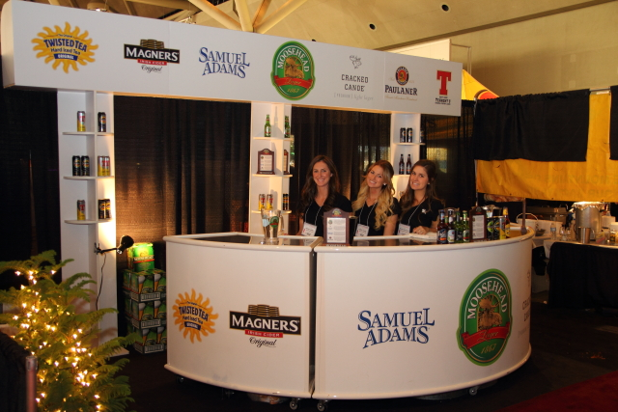
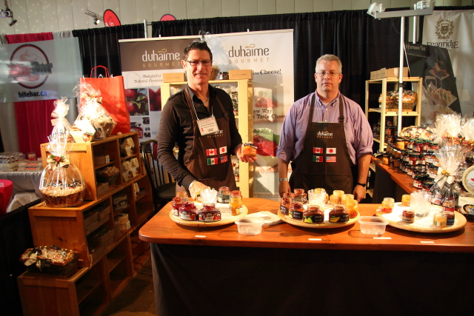
- Here are some visuals of good examples for booth designs and decor

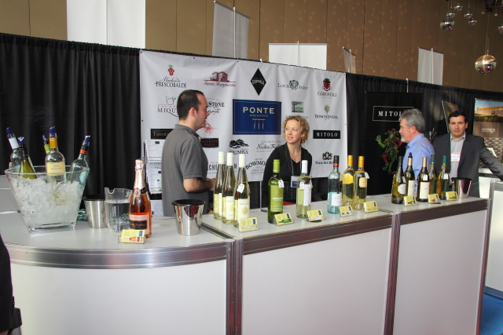
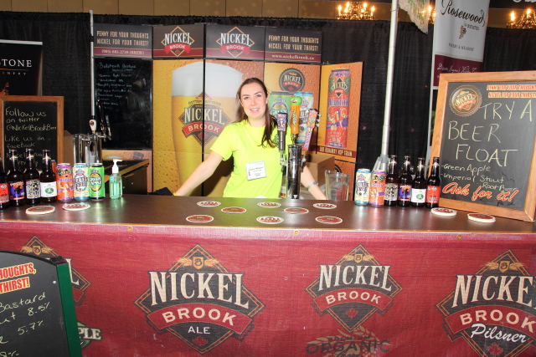

ELECTRICAL | POWER
- Showtech is the exclusive Electrical provider for MTCC, details in Exh Manual.
- Butane canisters, 5 lb or less propane and all electrical appliances are permitted.
- You cannot produce smoke without hoods and only table top deep fryers allowed.
INSURANCE
- You must have insurance naming the event, facility etc – details in Exhibitor Manual.
- Most business insurance policies will allow the addition of events at no charge.
- Alternatively you can purchase event insurance through our Exh. Manual forms.

MTCC
- You may require parking passes; wifi, phone lines, cleaning etc see Exh. Manual.
- Note: Free Wifi in 20 min intervals for guest access (reconnect every 20 minutes).
HOTELS
- A list of preferred hotels and rates is available under Hotel Partners

MUSIC
- No Djs are permitted, no mic’d presentations or volume above 70 decibels

FOOD SERVICE
- Be gourmet! Please consider all items. Is this our best effort for a gourmet audience?
- 2-3 food samples per 10x10. Focus on items that showcase your talents but are easy to prep, serve and eat with one hand or fork only. Most guests are also holding a glass.
- Clear signage, visible from a distance with a list of items and price for each i.e. chalkboard and plexi or framed table signage. Showcase a sample of each if possible.
STAFFING
- 2 or 3 staff minimum for serving per 10x10 plus extra people for prep, relief etc.
- Train staff to provide an important message about your brand, something that will deliver results. You have a moment of undivided attention, make it memorable.
- We recommend no phones, sitting, eating or drinking, engage your guests!
- If you require trained, professional staff at the show see Bevsupport Staffing Form
ADDITIONAL OPPORTUNITIES
- Apply to host a demo on the Chef Stage or Trend Central Tasting Stage – FREE!
- Provide 5 x $50 or more in prizing for inclusion in a top tier radio promotion and online.
- Provide a $2500 or more Grand Prize for a dedicated pre show marketing campaign.
- For advance and post show promotion consider an inexpensive online ad with gourmet.
- Target your customers with a professional ad in the Official Expo Guide. Due Oct 21.

Gourmet Food & Wine Expo is an experiential style event attracting affluent, well-educated and socially active guests. They spend significantly more on premium products, gourmet brands and dining than the average consumer. The Expo offers a diverse array of premium products, stylish decor, live entertainment, complimentary stages and incredible educational features including our highly regarded Tutored Tastings Wine Education Program. The Expo is celebrating its 21st anniversary and is Canada’s largest international wine appreciation event. We are thrilled to have your team as part of this incredible annual celebration of all things gourmet! Please contact your show management team professional for any further questions. Thanks so much and we look forward to working with you!

OFFICIAL RULES & REGULATIONS

All exhibits and exhibitors are required to abide by all rules and regulations included in addition to the exhibitor rules and regulations as stipulated on the Exhibit Space Contract. All exhibits and exhibitors must also comply with the Metro Toronto Convention Centre Rules & Regulations. The Gourmet Food & Wine Expo may add, adjust or amend these rules and regulations as necessary to ensure the safety and security of the event, its property and all exhibitors, staff and guests associated with the event and venue. In all cases interpretation of the rules and regulations shall rest with Show Management and its decision shall be final. Metro Toronto Convention Centre, Town Media, along with all subsidiary and parent companies and all staff, are not liable for any damages or losses incurred as a result of participation or association with the Gourmet Food & Wine Expo.

GENERAL NOTICES

ACCOUNT PAYMENT
Full and final payment for exhibit space must be made prior to move-in. Show Management reserves the right to refuse entry to any exhibitor whose account has not been paid in full.

AISLES AND COMMON AREAS
Are not to be used by individual exhibitors. No solicitation may be conducted in the aisles, foyers or common areas. Flyers, incentives and signage are not permitted in any common areas without express prior written approval by show management and may involve a sponsorship agreement. Any unauthorized solicitation or distribution in the aisles or common areas will be subject to fines of $1000 or more per incident.

INSURANCE
Each exhibitor must carry full insurance for the entire duration of the show, including move-in and move-out. Proof of insurance must be provided to Show Management prior to move-in.

LIGHTING
Ambient low-level lighting is used to enhance the overall show atmosphere. Exhibitors are encouraged to bring or order individual booth lighting. See Showtech section for order forms.

PROMOTIONS AND CONTESTS
Sales promotions and competitions conducted by exhibitors in conjunction with their display must be free of any obligation on the part of the winner. Prize winners must not be required to place an order before collection the prize offered. The schedule of prizes and terms of the competitions must be clearly stated on an entry form. Descriptions of competitions must be submitted in writing to Show Management at least four weeks prior to the expo.

SAMPLE SALES – NEW FRAUD PREVENTION STEPS WIL BE TAKEN
ALL EXHIBITORS MUST ACCEPT SAMPLE TICKETS. This is the official currency of the expo. The Sample Ticket Redemption Office is located on site in room 204 of the MTCC (in the main foyer; adjacent from badge registration). The currency for sample purchases will be $1.00 tickets. Buckets will be issued to each exhibitor to hold tickets and must be returned at the end of the Expo. We will deduct $10 per vendor for unreturned buckets. Tickets are then weighed at the ticket redemption office and a receipt is issued. NEW! All tickets will be bagged and tagged by vendor by day for verification. Any fraudulent tickets will be removed, any variance due to weighted tickets will be adjusted for in the post show due diligence. Wet tickets will NOT be weighed until completely dry. Fraud features and details on how to verify all tickets are legitimate will be distributed to vendors on site at the Expo. Cheque reimbursements will be issued within approximately six weeks.

SOLICITATION
Distribution of samples, souvenirs, promotional materials and soliciting of business must be within the exhibitors’ booth space. Such activities are not permitted in the aisles, restaurants, registration area, hallways or other exhibits. No exceptions will be made. Booth personnel, including demonstrators, receptionists and models are required to confine their activities to within the exhibitor’s booth space. Please call or email show management if you wish to distribute materials in the Official Expo Bag.

SPECIAL OCCASSIONS PERMIT – ALCOHOL VENDORS
All alcohol to be sampled or served at the Expo must be purchased using the event SOP which will be available two months prior to the Expo. Please have your purchase receipts available at the booth at all times, as well as scan a copy prior to arriving on site to jodell@postmedia.com.

THEFT PREVENTION
It is recommended that the exhibitor remove all articles of value from their booth each night at Expo close. Show Management will take all reasonable security measures; however, removal of valuable items will minimize the possibility of loss. Every precaution will be taken to prevent losses but neither Show Management nor the Metro Toronto Convention Centre will be held responsible for personal injuries, losses, or damage to products, stands, equipment, and decorations, resulting from fire, accident, theft or other, while in the building. Each booth and all its contents is solely the responsibility of the exhibitor or sponsor.

BOOTH REGULATIONS | GUIDELINES

BOOTH INCLUSIONS
The following services are provided compliments of Show Management:
8’ high black back wall and 3’ high black side walls, Burgundy aisle carpeting and daily cleaning of aisles, 24 hour building security and use of shared secure storage upon request, Ice delivery to your booth and use of shared refrigeration truck, the first 10 bags of ice are complimentary and there will be an $8 charge for each additional bag.

BOOTH SHARING
Booth sharing is not permitted. All products represented within your exhibit space must be wholly owned by the corporation or company booking the exhibit space. The official agency of record may book booth space to present products they represent. Any exhibitor subletting or promoting products that they do not officially represent will be fined $1000 per occurrence.
CARE OF RENTED SPACE
Exhibitors must ensure space rented for their booth remains in good condition. Any fastening done in the building must not deface any floors, pillars, walls or ceilings. Exhibitors may not paint the floor space in their displays or drill or damage the floor in any manner. It is forbidden to apply any non removable substance to the floor surface. Stickers of any kind are prohibited at the MTCC. Exhibitors may not put written materials on the walls of the Convention Centre. Acceptable tapes to be used are #618 Suretape (Cloth Duct Tape), #C700 Arno Tape (Double Sided Tape). Exhibitors will be charged for repairs or cleaning if these rules are not enforced. Furthermore, exhibitors will be entirely responsible for damages incurred to material lent or rented (dividers, drapes, carpets, etc.) and will have to pay for repairs or replacement.

CARPET OR FLOOR COVERING
Carpet or an adequate floor protection that has been approved by the Metro Toronto Convention Centre is mandatory in every booth.

DISPLAY RULES
To maintain consistency from show to show, the trade show industry has established guidelines for booth construction. Gourmet Food & Wine Expo exhibitors must conform to these guidelines. Management may require exhibitors to make alterations to their displays and on failure to comply, may order the immediate removal of the entire exhibit at the Exhibitor’s expense without compensation.

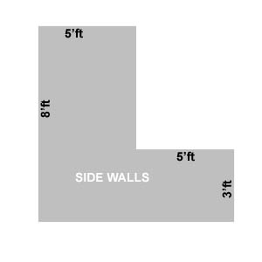
1. An allowance of one inch is made on either side of the display to allow for the thickness of standard dividers. If lengths exceed 9’ 10”, notify show management so special arrangements may be made.

2. Projection of sidewalls must be limited to a maximum of five feet from the rear of the booth, allowing for 50% visibility at the sides of the exhibit. They must not exceed beyond 5 feet and must drop to 3 feet beyond that point extending to the aisle.

3. All sides and surfaces of exhibits (booths and signs), which are exposed to view, must be properly finished and decorated.

EXHIBIT INTEGRITY
Show Management reserves the right to restrict the use of glaring lights, objectionable lighting effects, or exceptionally noisy machinery. Sound presentations, slides, or movies will be permitted, if tuned to conversational level and, if not objectionable to neighbouring exhibitors. Sound levels may not exceed 70 decibels more than 4’ from the source. Exhibits must not cause or produce any unusual, noxious or objectionable smoke, vapours, gases or odours.

PREFABRICATED BOOTH
An exhibitor planning to use or build a prefabricated display should make sure that:
A. An allowance of one inch is made on each side of the display to allow for the thickness of standard dividers. If lengths exceed 9’10”, notify Show Management so that special arrangements can be made.
B. Projection of sidewalls must be limited to a maximum of five feet from the rear of the booth,
allowing for 50% visibility at the sides of the exhibit.
C. All sides and surfaces of exhibits (booths and signs) that are exposed to view must be properly
finished and decorated.

SIGNAGE/BANNERS/DECORATIONS
The MTCC allows banners to be suspended above booths. The ceiling is 35’ high. The regulations
controlling installation are:
A. Signage above the 8’ drape line must be approved in advance by Show Management. Signage is required to be within the airspace directly above your booth and must not interfere with the adjacent exhibits.
B. All signage must be professionally made and displayed.
C. Graphic material may appear on both sides of banners.
D. Showtech must do all installations. While every effort will be made to hang signage according to the exhibitor’s requirements, we cannot guarantee that your individual banner will be hung at the center of your booth.

GENERAL LOGISTICS

BARBEQUES
Please note that use of an open flame barbeque is not permitted. Some types of grilling equipment may be used if pre-approved by Show Management and the MTCC and may require smoke extractor.

ICE
Ice will be delivered daily to exhibitors. Exhibitors are responsible for bringing their own bus pans and water jugs. Please label your items clearly to avoid confusion. Each exhibitor who requires ice will receive the first 10 bags complimentary and there will be an $8 charge for each additional bag required.

INDOOR USE OF PROPANE AND GAS
Please contact Show Management for approval form.
A. Cylinder capacity must not exceed 5 lbs of propane.
B. A person knowledgeable in the safe operation of the appliance must remain in attendance whenever the appliance is operating.
C. Regular or continuous monitoring that carbon monoxide in the vicinity of the appliance does not exceed 15 pm. (Maximum time between checks is 3 hours).
D. Means shall be provided to protect the public from contact with hot surfaces or open flames.
E. A 5 lb ABC fire extinguisher must be provided.
F. No overnight storage of propane cylinders.
G. A cylinder shall not be located within 50’ of an exit or stairwell.

REFRIGERATION
Space in the refer trailer is limited, to daily inventory. The refer truck is parked at the loading dock and under 24 hour security. Product should be clearly identified, as other exhibitors will be sharing truck space.

RINSE STATIONS
There will be three glass rinsing stations on the show floor for show patrons only. Please do not dump into the rinse stations as they overflow.

SINKS
One shared sink for all exhibitors will be available on the show perimeter. If you require your own sink please order through Showtech.

SPIT BUCKETS
Exhibitors are required to provide their own spit buckets. A limited number may be available onsite but vendors are strongly encouraged to bring their own spittoon and pitchers for rinsing glasses.

MOVE IN | MOVE OUT | PARKING | STORAGE

MOVE-IN RULES
The exhibitors may NOT begin move-in until the full rental amount has been paid. Neither Town Media Inc., its representatives, nor the MTCC shall be responsible for damage to all materials brought into the MTCC. During move-in and move-out, the MTCC is considered a construction site and it is highly recommended that all workers must wear protective footwear as stipulated in the Occupational Health & Safety Act. All exhibitors must move-in & out through the North Loading Ramp (located on Front St. & John St.). No equipment or materials can be transported via the public passenger elevators or escalators. All large vehicles requiring a loading bay are required to check into the marshalling yard. Exhibitors are required to have an authorized representative of the agency at your booth at all times.

MOVE-OUT RULES
Exhibitors are not permitted to dismantle booths prior to official show closing. Crates will be returned and dollies will be allowed in the hall after the aisle carpets have been removed. When all exhibitor material is completely packed up and delivered to the loading dock their vehicle will be allowed to enter the loading area as space becomes available. Exhibitors must vacate their rented space and the MTCC along with all goods by Sunday at 11:00 pm. Equipment left on the floor after 11:00 pm will be stored by Lange Transportation and Storage. A charge will be levied for shipping and storing materials at their warehouse in Malton, ON.

PARKING
Parking in the North loading dock is absolutely prohibited and all vehicles must be removed as soon as they are unloaded, otherwise, they will be towed away at the exhibitor’s expense. The time allocated to discharge merchandise is a maximum of 30 minutes, after which time parking is available at the North Parking entrance off Lower Simcoe St as well as on Queen’s Quay West near Harbourfront. Parking passes are ordered through the MTCC. See MTCC Exhibitor Parking Pass Order form in the Additional Order Forms section.

STORAGE
Crates, boxes and packing materials must be removed from the booths if no storage space is available within them. They will be stored and returned to the booths at the closing of the exhibition. Please ensure that all material is clearly identified.

STAFFING | EXHIBITOR BADGES

STAFFING REQUIREMENTS
All staff must be 19 or older, no underage visitors or staffs are permitted under any circumstance. Exhibitors must have staff in their exhibit at all times during the show hours and for half an hour prior to show open and a past show close. It is recommended at least one staff member stays until all visitors have left the building which can take up to one hour. Show Management does NOT assume any responsibility for losses. Staff must always carry valid ID.

EXHIBITOR BADGES
Exhibiting companies are required to submit the exhibitor badges online no later than two weeks prior to show open. After this time registration is available onsite only for a nominal fee per badge. All exhibitor badges are to be picked up at Exhibitor Registration during move in and show hours only. Wristbands will also be issued with each badge and exhibitors must have a badge AND a wristband to enter the Expo. New badges and wristbands can be purchased with proper ID at the Exhibitor Registration area. Badge passing will not be tolerated. At each entry and exit point you may be required to show identification that corresponds with your badge. Your badge will be confiscated without valid ID.

REFUSAL OF ENTRY
Show Management reserves the right to refuse admission to the show building to any visitor, exhibitor or exhibitor’s employee(s) who, in the opinion of Show Management, is unfit, intoxicated or in any way creating a disruption to the show.

SMART SERVE
All staff members that will be handling and serving alcoholic beverage MUST BE SMART SERVE CERTIFIED. Please see the online certification course link in the Exhibitor Manual Section of the website. Please carry your SMART SERVE card at all times.

